**Title : Count Method**

1. **Task Description**

Build a python program which returns the no. of paragraphs , count of words, count of sentences and doc size of .txt document.

1. **Task Output Screenshot**

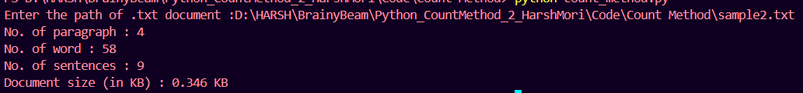

1. **Widget/Algorithm Used In Task**

* **Paragraph Count**: Splits the text using “\n\n” as paragraphs are often separated by double line breaks.
* **Word Count**: Uses a regular expression “\b\w+\b” to match all words in the text.
* **Sentence Count**: Splits the content using sentence-ending punctuation marks ., ?, and !.
* **File Size**: Calculates the file size using “os.path.getsize()”.